Australian Unmanned Systems Academy
SCENARIO 4 – Wondai State High School
PROPOSED FLIGHT PLAN
Due Date 03/08/2021 Date Submitted 03/08/2021
Student Name Your Name School Your School
Mission Objectives:
The customer requires a topographical map of the entire Wondai State High School. (QLD)
The school is located at -26.41903°, 146.23587° Decimal. Elevation of the cemetery is 972 Feet

The flight plan for this mission is shown in Figure 2, and has been determined to be both legal and viable.
- Determine the viability of the mission.
- Plan and detail the mission, and prepare a detailed mission briefing for the company Chief Pilot
A layout of the Wondai State High School as provided by the client is shown in Figure 1
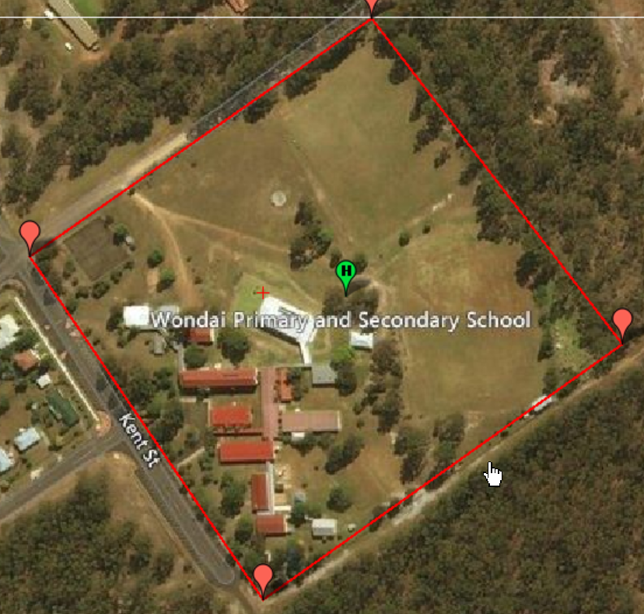
Figure 1 Wondai State High School

Mission Brief:
The following flight plan has been developed for the mission in order to satisfy both CASA regulations and the customer requirements.
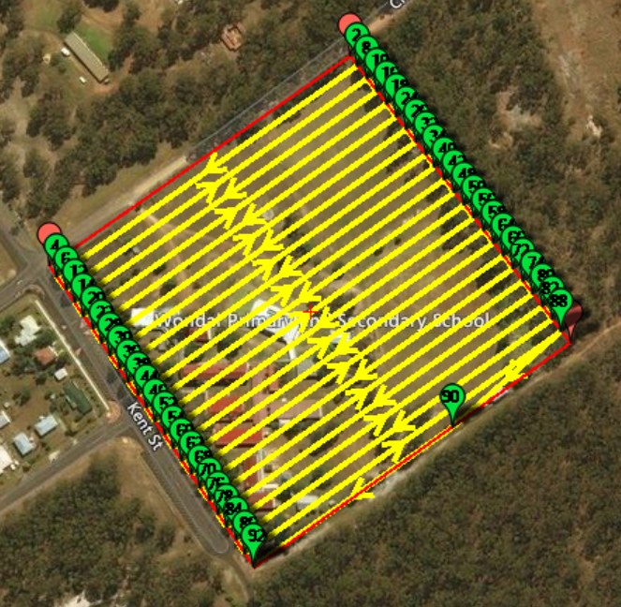
Figure 2 Proposed Flight Path

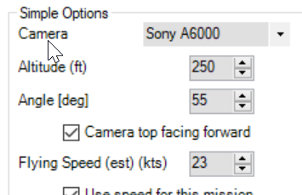

Figure 3 Mission Details

To achieve the required ground resolution of 1.5cm/pixel the mission will be flown at a height of 250ft AGL.
Referring to the Bundaberg VNC it is seen that Wondai is in Class G airspace. The FIA radio frequency to monitor is 124.6 Maryborough.
For this mission to proceed all that is required is for the school principal to give approval for flight above the school.
The area to be mapped is approximately 300m square, therefore to limit the distance the aircraft will travel away from the ground control station (GCS), and being mindful of the one visual line of sight distance requirement, it has been decided to locate the GCS in the centre of the school grounds. With the area to be flown is approximately 300m by 300m, the furthest the aircraft will travel away from the GCS is approximately 150m. The flight crew will therefore comprise a pilot and co-pilot only.
Although the entire flight plan is in Class G airspace, and there are no vertical obstructions, additional observers will not be required.
From the flight manual for the V-TOL Seeker aircraft, the maximum range of the aircraft in calm conditions is approximately 40klm. The school is located on the edge of the township of Wondai, and therefore a fly-away occurrence could place the aircraft over persons or property not associated with the flight.
The proposed flight time is under 9 minutes, and therefore only one flight battery will be required, and battery charging facilities are not required. A second battery will be included as a back-up only. During the flight 378 pictures will be taken, which will easily fit on the memory card fitted to the camera. A side lap and overlap of 80% has been chosen to provide best resolution.
As this is a school, and it is the school principal is requesting this flight, there will be no special access permissions required. It will however be necessary to restrict access to the school grounds (or utilise a student free day) during the flight to ensure that the flight is not conducted within 30M of persons not associated with the flight.
This flight is both legal and viable.

