Australian Unmanned Systems Academy

SCENARIO 2 – Bravo Charleville Cemetery

PROPOSED FLIGHT PLANbbb

Due Date 03/08/2021 Date Submitted 03/08/2021

Student Name Your Name School Your School

Mission Objectives:

The customer requires a topographical map of the entire Charleville cemetery.

The cemetery is located at 26° 24’ 7.42” S, 146° 14’43.3” E. (-26. 402062 °, 146. 24536 ° Decimal). Elevation of the cemetery is 299.65 Meters (983.1 Feet)

The flight plan for this mission is shown in Figure 2, and has been determined to be both legal and viable.

* Determine the viability of the mission.
* Plan and detail the mission, and prepare a detailed mission briefing for the company Chief Pilot

A layout of the Charleville Cemetery as provided by the client is shown in Figure 1

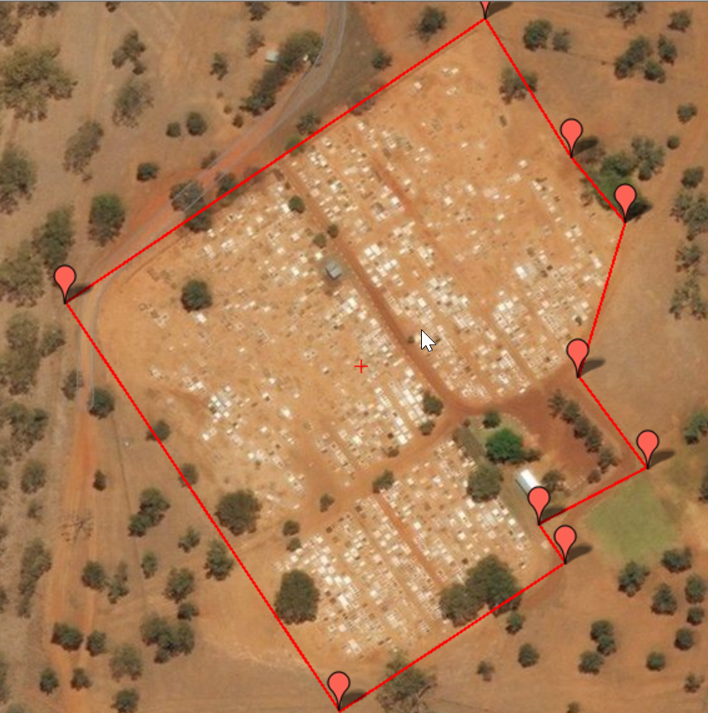

Figure 1 Charleville Cemetery

Mission Brief:

The following flight plan has been developed for the mission in order to satisfy both CASA regulations and the customer requirements.

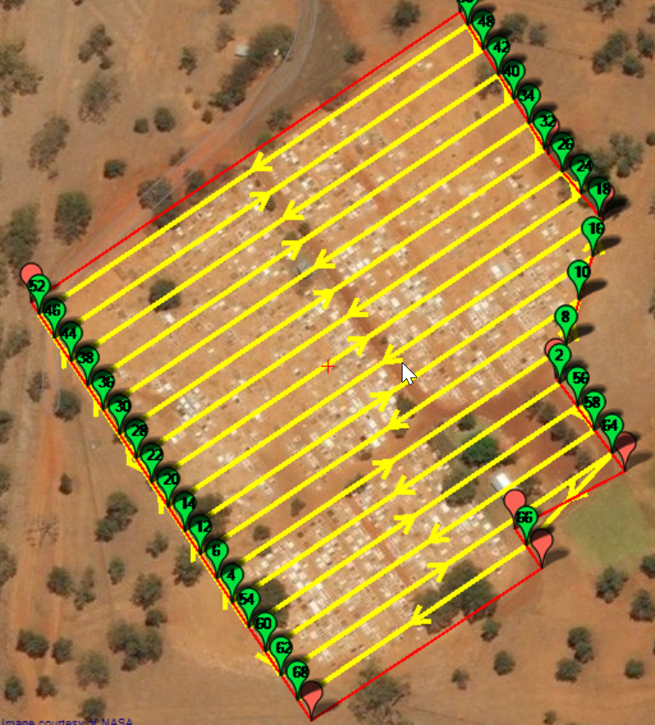

Figure 2 Proposed Flight Path



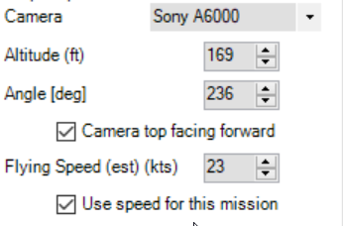

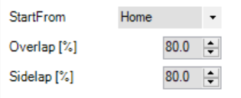

Figure 3 Mission Details

To achieve the required ground resolution of 1cm/pixel the mission will be flown at a height of 169ft AGL.

Referring to the ERC Low National it is seen that Charleville is in Class G airspace. For this mission to proceed all that is required is that the owner of the cemetery (local shire council) give approval for flight above the cemetery.

To limit the distance the aircraft will travel away from the ground control station (GCS), and being mindful of the one visual line of sight distance requirement, it has been decided to locate the GCS in the centre of the cemetery. As the area to be flown is approximately 200m by 200m, the furthest the aircraft will travel away from the GCS is approximately 100m. The flight crew will therefore comprise a pilot and co-pilot only.

Although the entire flight plan is in Class G airspace, and there are no vertical obstructions, observers will not be required.

From the flight manual for the V-TOL Seeker aircraft, the maximum range of the aircraft in calm conditions is approximately 40klm. The cemetery is located outside the township of Charleville, and therefore a fly-away occurrence would not place the aircraft over persons or property not associated with the flight.

The FIA information has been gained from the Brisbane Visual Terminal Chart (VTC), which indicates that the radio frequency to be monitored for this area is 129.0 (Mt Glorious)

The flight crew will comprise TWO persons, being Pilot in Charge and Co-Pilot.

The proposed flight time is under 8 minutes, and therefore only one flight battery will be required, and battery charging facilities are not required. A second battery will be included as a back-up only. During the flight 413 pictures will be taken, which will easily fit on the memory card fitted to the camera. A sidelap and overlap of 80% has been chosen to provide best resolution.

As this is a cemetery, and it is the local council that is requesting this flight, there will be no special access permissions required. It will however be necessary to restrict access to the cemetery during the flight to ensure that the flight is not conducted within 30M of persons not associated with the flight.

This flight is legal and viable-.